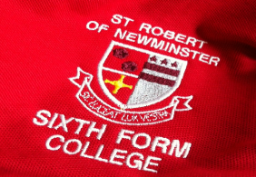
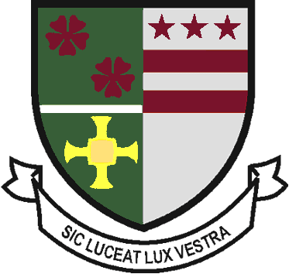
Sixth Form Uniform Order

Student Name : | Contact number :

Payments –Parent Pay,

Sixth Form Polo Shirt - £15.00

X SMALL | SMALL | MEDIUM | LARGE | X LARGE | XX LARGE | TOTAL
 |  |  |  |  |  | £

Sixth Form Hoodie - £20.00

X SMALL | SMALL | MEDIUM | LARGE | X LARGE | XX LARGE | TOTAL
 |  |  |  |  |  | £

Sixth Form V Neck Black Jumper (pre order only) £25.00

X SMALL  30" | SMALL  34" | MEDIUM  38" | LARGE  42" | EXTRA LARGE  46" | XX LARGE 50" | TOTAL
 |  |  |  |  |  | £

Sixth Form Crew Neck Black Jumper (pre order only) £25.00

X SMALL  30" | SMALL  34" | MEDIUM  38" | LARGE  42" | EXTRA LARGE  46" | XX LARGE  50" | TOTAL
 |  |  |  |  |  | £

Please return to - Sixth Form Admin, St Robert of Newminster School & Sixth Form College, Biddick Lane,
Washington, Sunderland, Tyne and Wear, NE38 8AF or sixthform@str.bwcet.com

Office use only – Total Amount paid Parent pay
£

