6th Form  Preparation work for  PHOTOGRAPHY  Summer 2022 | Read  Task 1:  Read this article on the ‘Visual Elements’ which will prepare you for your photography task  Visual Elements Article 1  Visual Elements Article 2  Time: 1hr | Watch  Task 2:  Watch this YouTube video discussing the ‘Visual Elements’ and showing examples of how you can create them in your photography – watch till 8.48  Examples of the Visual Elements  To prepare you for using DSLR camera’s in September watch the following video  Technical Photography Terms  Time: 1hr | Record  Task 3: Gather inspiration and take at least 30 photographs  Take photographs of the following theme to help you begin your journal.  - Texture  Challenge: Use aperture in your photographs (you can achieve this with any camera by focusing on one area of the image to blur the background or foreground) Consider which digital experiments and physical experiments you may explore.  CLICK: to see examples on Pinterest to help you  Time: 1hr
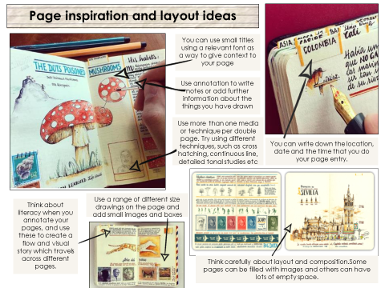
Complete/Present
Time: 5 hrs

Task 4: Editing and Presenting your photographs
WHAT? Create a PowerPoint of to present your photography work over the next few weeks.
- Save PowerPoint as ‘Bridging work - A ‘Level Photography’
- The PowerPoint will be printed in September for you to make your photography journal. The visual photography journal will reflect aspects of your own life, interests and personality in a small A5 sketchbook, altered book or handmade journal.

HOW? Create a contact sheet of all the images you have taken to capture ‘Texture’.
- Edit your most successful photographs using Photoshop (you can download free trails) or alternatively use editing sites such as Pixart, Gimp and Frog.
- Consider how you will present your journal in September; you may want to begin prepping titles for each page and small scale drawings and experiments from your own photography to include. You gain marks in Photography for relevant sketches and drawings as well as your own photographs (see example of a journal page >>>>>>>>>>>>>>)
- Use the terminology you have learnt from the articles and YouTube videos to annotate how you have created ‘Texture’ in each photograph and how you have edited your most successful ones, if you have found artist which link to your photographs discuss how you have used the same visual elements as them to influence your works.
- Reference the work of a photographer that has inspired you ( gather basic information)
Challenge: Create an artist research on a photographer of your choice which has been inspired by your own photography.
WHY? To develop photography skills and observation drawing skills by looking more closely at things around you that you see every day, and to explore skills needed to create successful photographs.

- To be prepared for September you may wish to begin buy OR make an A5 sketchbook. You could use parts of an old reading book/sketchbook…it’s also just as easy to make your own - look at some of these examples for ideas, just use whatever you have available at home (see Mrs Scatchard’s video of the one she has made from old papers on strobsart Instagram)
- As part of your A ‘Level studies you are expected to keep an A5 journal alongside your coursework. A photography journal is the same as a written journal, except that it incorporates colours, images, patterns, and other materials. Some photography journals have a lot of writing, while others are purely filled with images.

WHAT WILL I TAKE PHOTOGRAPHS OF? Each double page will have a theme (we have several themes to start you off with and will release the themes on a fortnightly basis, your first is Texture. These themes should take you up to at least the Summer term. You can edit your photography digitally but also create experiments with them physically; you can draw from your own photography. Look at photographers and artists who have experimented with their photography both digitally and physically below.
Challenge: Create physical experiments with your photography inspired by an artist of your choice. Digitally manipulate your images in various ways using inspiration from photographers.
Digital Experiments:
You could create ‘Mirrored Images’

Physical Experiments:
You could create paper folds in the style of Abigail Reynolds

This week’s theme is TEXTURE:
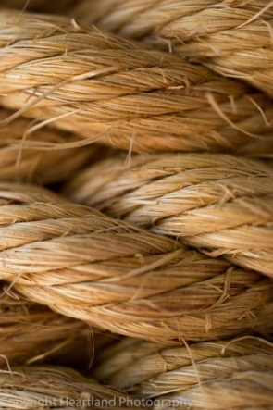
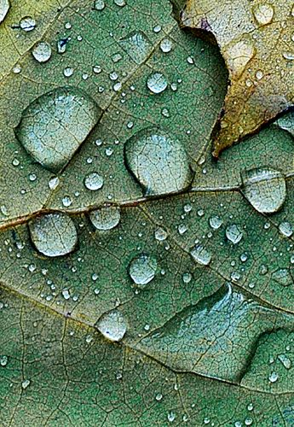

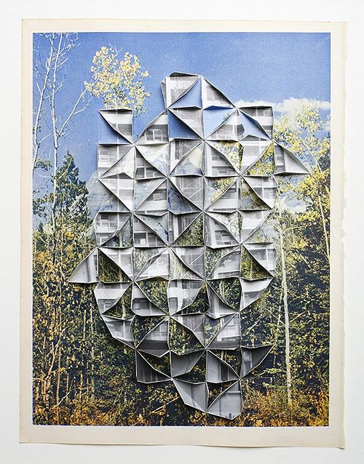
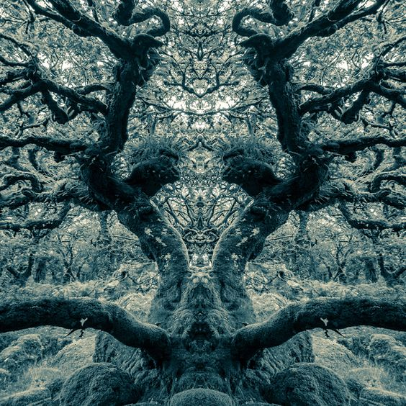

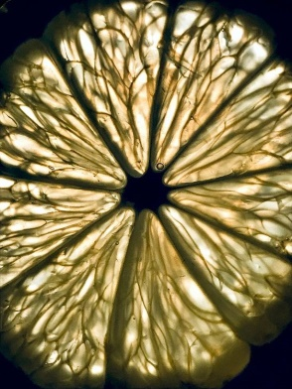
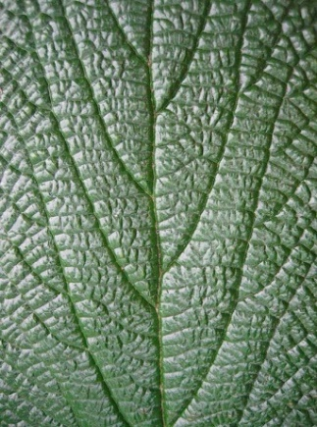

Email your PowerPoint/images of your work experiments to:
Nscatchard@str.bwcet.com

