6th Form  Preparation work for  Mathematics  Summer 2022 | Listen to this podcast from Brian Cox and Robin Ince as they discuss the joy of numbers.  Numbers, Numbers Everywhere podcast  Time: 30 mins | Complete the worksheet in the folder named ‘Corbett Maths Indices’. Use the link on the front of the booklet if you need support.  Time: 30 mins | Explore why any number  to the power of 0 is 1  Research why this is. Can you then articulate it yourself? Can you write an explanation in words or diagrammatically?  Time: 1hr
Complete the worksheet in the folder named ‘Surds examples and revision questions’. Mark your work using the answers.  Time:1 hr | Listen to this podcast highlighting some of the best Mathematical stories from around the world.  Relatively Prime podcast  Time: 25 mins | Complete the worksheet in the folder named ‘Indices examples and revision questions’.  Time: 1hr | Explore  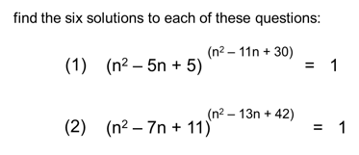  Hint: rules of indices, solving quadratics  Time: 30 mins
Watch the video giving you some study tips for starting Year 12 Maths.  Study Tips for Year 12 Maths  Time: 5 mins | Read the information about rational numbers which links to rationalising the denominator with surds.  What is a rational number?  Time: 15 mins | Complete the worksheet in the folder named ‘Corbett Maths surds’. You only need to complete the Apply questions.  Time: 1 hr | Read why Florence Nightingale is actually a well known mathematician.  Florence Nightingale  Time: 15 mins

