6th Form  Preparation work for  ART  Summer 2022 | Read  Task 1:  Follow the link below and browse a range of resources that will help you prepare you for Art at A ‘Level. Keep this site in mind as it will be handy to revisit every now and then!  Student art guide  Time: 1hr | Watch  Task 2: How to make an Art Journal  Check out the link and look on YouTube for ideas linked to handmade artist sketchbooks:  Sketchbook ideas and making your own journal - scroll down the page and click on  ‘2.MAKING YOUR SKETCHBOOK YOUR OWN’  Time: 1hr | Record  Task 3: Gather ideas/ inspiration  Take photographs of the following themes to help you begin your journal.  - Inside  - Outside  See examples and artist inspiration below to help you!  Time: 30min
Complete/present
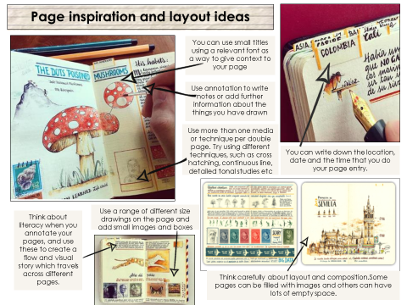
Time: 5-6hrs

Task 4: Making your Art Journal
WHAT? Create a visual art journal which reflects aspects of your own life and personality in a small A5 sketchbook, altered book or handmade journal.
HOW? Use a combination of drawings, paintings and text/words to illustrate the suggested themes using a range of materials, techniques and processes.
WHY? To develop and refine your observation drawing skills by looking more closely at things around you that you see every day, and to explore skills in creating drawings from imagination.

- To begin with you will need to buy OR make an A5 sketchbook. You could use parts of an old reading book/sketchbook…it’s also just as easy to make your own - look at some of these examples for ideas, just use whatever you have available at home.
- As part of your A ‘Level studies you are expected to keep an A5 journal alongside your coursework. An art journal is the same as a written journal, except that it incorporates colours, images, patterns, and other materials. Some art journals have a lot of writing, while others are purely filled with images.

WHAT WILL I DRAW? Each double page will have a theme (we have 30 themes to start you off with and will release the themes on a fortnightly basis) which should take you up to at least the Summer term. You can draw from direct observation, use your own photos or find images on the internet as inspiration. Look at the slides below with artists who use sketchbooks and journals.
You can add more pages and continue it over the Summer too, ready to bring back in September.
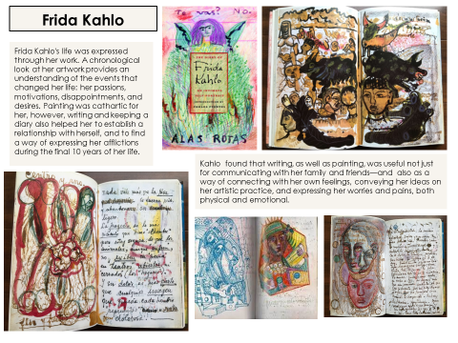
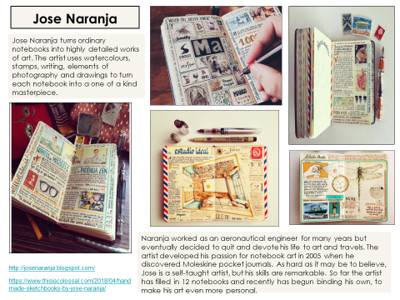
Artist inspiration:

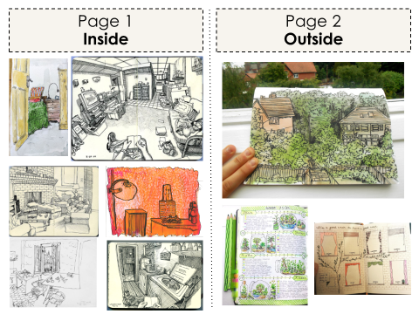

This week’s themes:

Email updates/ images of your work to:
Nscatchard@str.bwcet.com

