Signposting Pupils to Articles in the Kooth Magazine

Go to www.kooth.com to Register using our Sign Up Sheet
Once logged in, go to the Newspaper Icon highlighted below, click ‘Categories’ and this will then take you to all Topics in the Kooth Magazine.
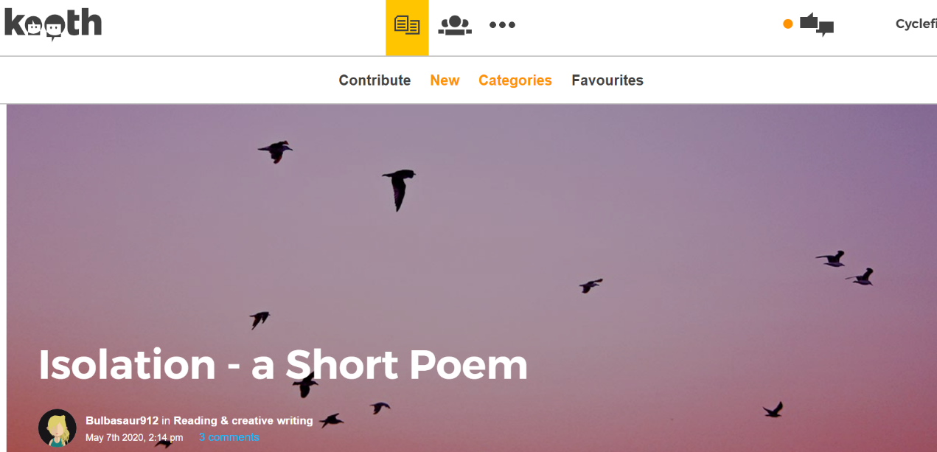

Example
Click Newspaper Article Icon, ‘Categories’ ‘Education’ which will then display sub-headings below:
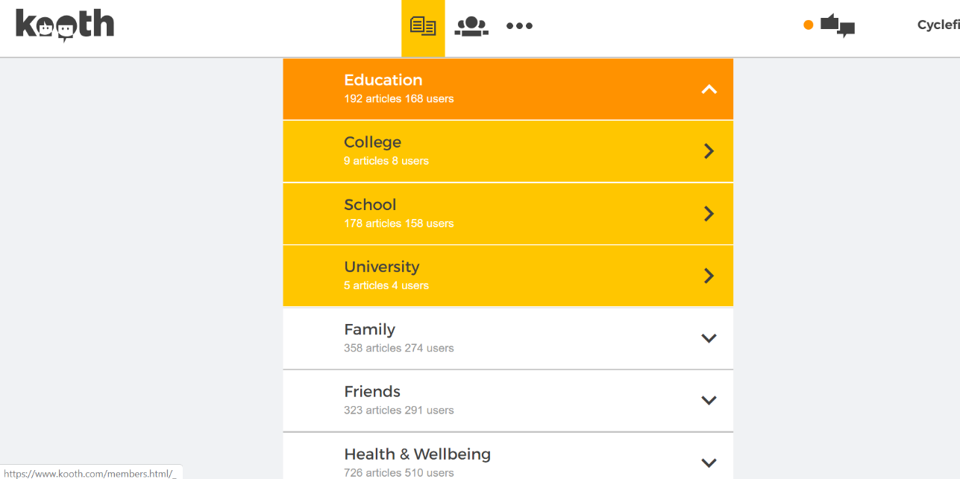

Kooth Magazine Articles www.kooth.com

All content is age appropriate, clinically approved and fully moderated. Articles explore personal experiences, stories, poems, creative writing, written by young people. We also have our Kooth Content Team who write for the Kooth Magazine. Their articles keep our Kooth members up to date with the latest information, advice and guidance exploring a huge range of topics!
The below articles are written by our Kooth Content Team (remember to click the Newspaper Icon to then navigate to ‘Categories’ to select the topic you wish to view).

The Impact of Coronavirus on GCSE’s and A-Levels (April 16th 2020)
Click ‘Categories’ ‘Education’ ‘School’

All About Exam Stress (Jan 17th 2020)
Click ‘Categories’ ‘Education’ ‘School’

Going Back to School How is it for You? (Jan 8th 2020)
Click ‘Categories’ ‘Education’ ‘School’

Study Tips (Jan 8th 2020)
Click ‘Categories’ ‘Education’ ‘School’

Choosing your GCSE’s (May 6th 2020)
Click ‘Categories’ ‘Education’ ‘School’

Staying at School During the Coronavirus (March 27th 2020)
Click ‘Categories’ ‘Education’ ‘School’

Let’s Talk About: Back to School (Aug 12th 2019)
Click ‘Categories’ ‘Education’ ‘School’

Safety Tips For Isolation (March 24th 2020)
Click ‘Categories’ ‘Health and Wellbeing’ ‘Health and Illness’

Coronavirus: The Latest (April21st 2020)
Click ‘Categories’ ‘Health and Wellbeing’ ‘Health and Illness’

Ten Ways We Can Manage Coronavirus Panic (March 27th 2020)
Click ‘Categories’ ‘Health and Wellbeing’ ‘Health and Illness’

Homebound Hobbies (May7th 2020)
Click ‘Categories’ ‘Hobbies and Interests’ Hobbies’

Understanding Eco-Anxiety (Feb 26th 2020)
Click ‘Categories’ ‘Mental Health’ ‘Anxiety’

Agoraphobia: What’s going on in my head? (Jan 8th 2020)
Click ‘Categories’ ‘Mental Health’ ‘Anxiety’

5 Ways to Deal with Anxiety (Jan 8th 2020)
Click ‘Categories’ ‘Mental Health’ ‘Anxiety’

Anxiety and Change (Aug 12th 2019)
Click ‘Categories’ ‘Mental Health’ ‘Anxiety’

Ten Rules for Coping with Anxiety (3rd May 2019)
Click ‘Categories’ ‘Mental Health’ ‘Anxiety’

The Fight or Flight Response (May 3rd 2019)
Click ‘Categories’ ‘Mental Health’ ‘Anxiety’

Celebs and Anxiety (May 2nd 2019)
Click ‘Categories’ ‘Mental Health’ ‘Anxiety’

Being Orthodox in Lockdown (May 5th 2020)
Click ‘Categories’ ‘Identity’ ‘Culture and Religion’

The Power of Sound for Wellbeing (May 4th 2020)
Click ‘Categories’ ‘Health and Wellbeing’ ‘Wellbeing’

