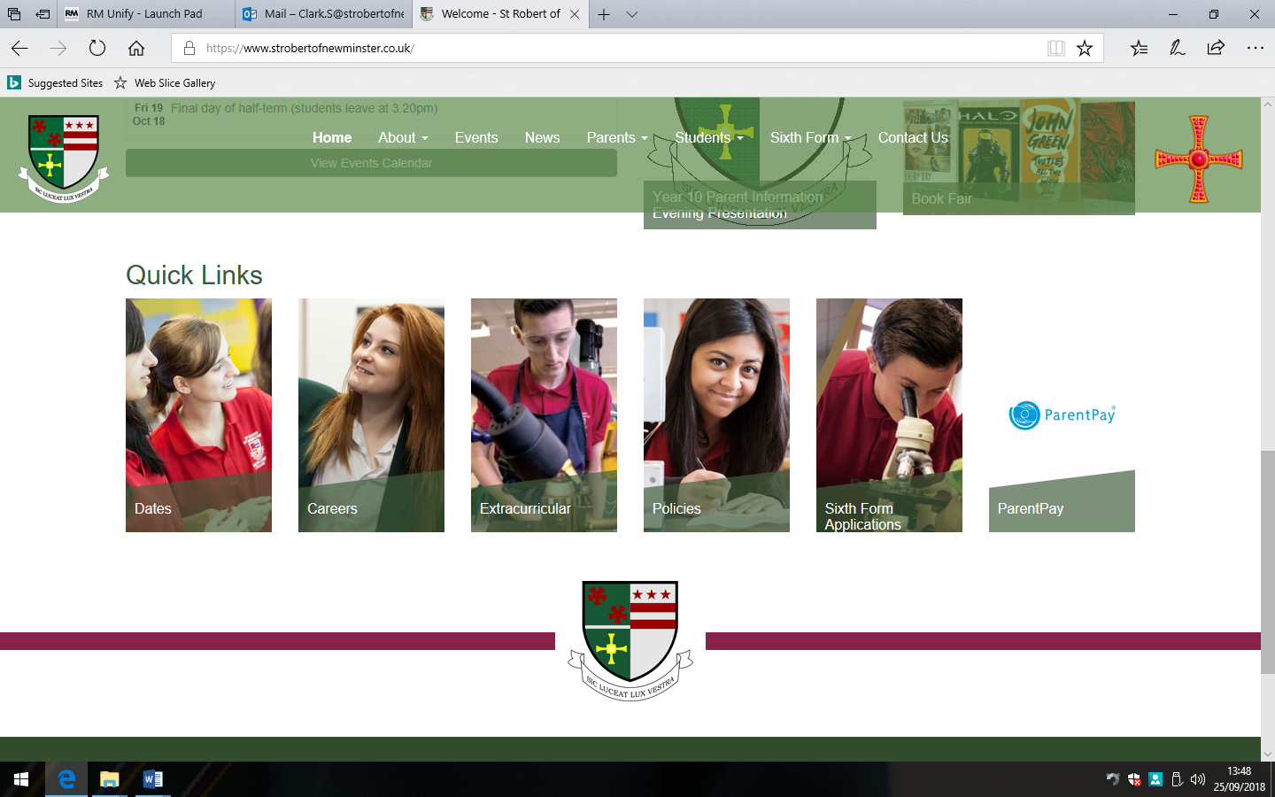
Year 7 Science

Year 7 Science Curriculum Information

 | Key Question: | Specification: | Skill Focus:
Term 1: | What is the link between energy and cells for our body to function? | - Safety in the Laboratory  - Energy  - Acids & Alkalis  - Cells | Developing safe practical skills  Subject knowledge recall  Scientific techniques  Graphing skills  Numerical and data handling  How Science works
Term 2: | Why are forces important in our understanding of the world around us? | - Simple Forces  - Solutions  - Reproduction | Developing safe practical skills  Subject knowledge recall  Scientific techniques  Graphing skills  Numerical and data handling  How Science works
Term 3: | How do chemical reactions take place and how do we recognise them? | - Chemical Reactions  - Space Physics | Developing safe practical skills  Subject knowledge recall  Scientific techniques  Graphing skills  Numerical and data handling  How Science works
Assessment | Time/Venue | What will be assessed?
1 : Linking to Term 1 | - Assessment held in-class  - 1hr  - Teacher assessed | Subject knowledge recall  Data handling  Numeracy skills  Problem solving  Describing graphical data
2: Linking to Term 1 and Term 2 | - Assessment held in-class  - 1hr  - Teacher assessed | Subject knowledge recall  Data handling  Numeracy skills  Problem solving  Describing graphical data
3: Linking to Term 1, Term 2 and Term 3 | - Assessment held in the Exam Hall  - 50 minutes  - Teacher assessed | Subject knowledge recall  Data handling  Numeracy skills  Problem solving  Describing graphical data
Year 7 Science Assessment Information

